 

**Placement Empowerment Program**

***Cloud Computing and DevOps Centre***

60 Days of DevOps Challenge

# ***Day 9****:**Docker Networking, Volumes, and Compose*

***Name: Mary Edlyn A Department: CSE***



**Challenge 1**: Write a simple Dockerfile that runs a Python script using an official base image (python:3.9)

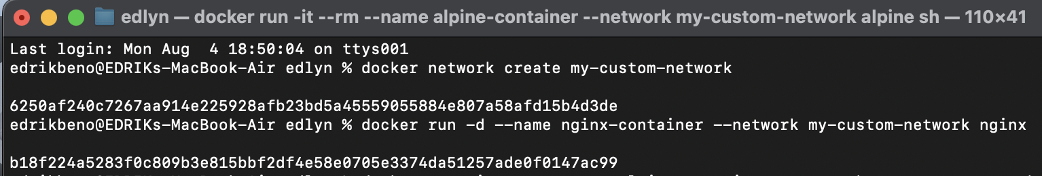

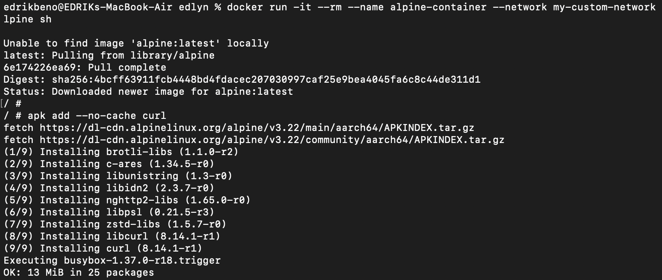

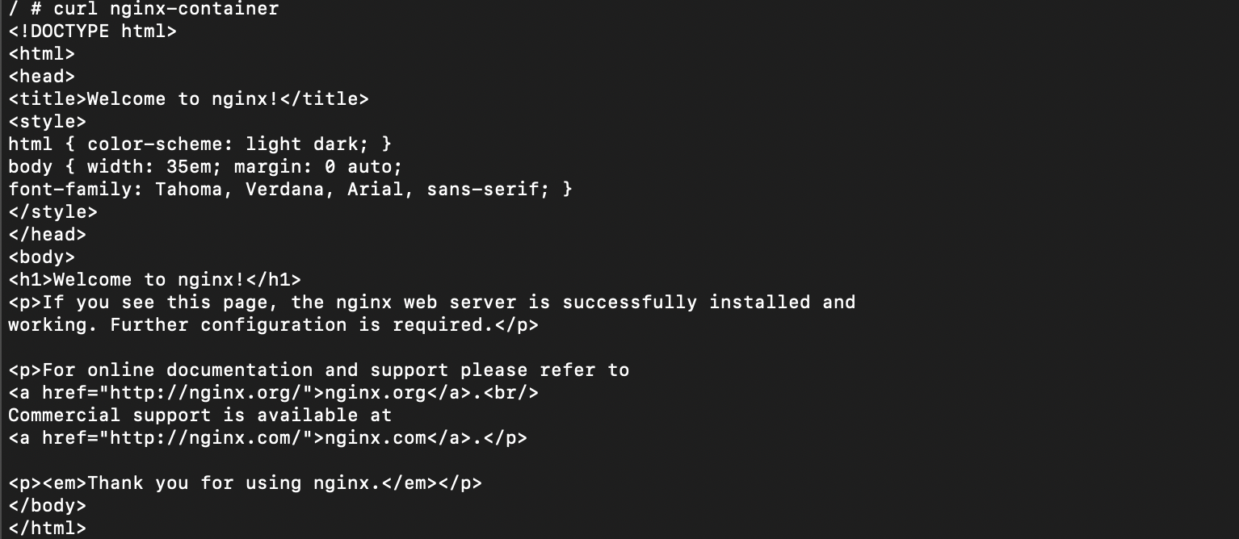

### Challenge 2:  Run a MySQL container with a named volume and confirm data persistence

